=========================Model Abstraction==============================
Big Picture First
Without LangChain:
response = openai.chat.completions.create(...)
works. But the moment you need:

switch providers
reuse prompts
inject variables
chain steps
add memory
stream
tools
agents
structured outputs
orchestration

Your code becomes chaos. LangChain solves this with:
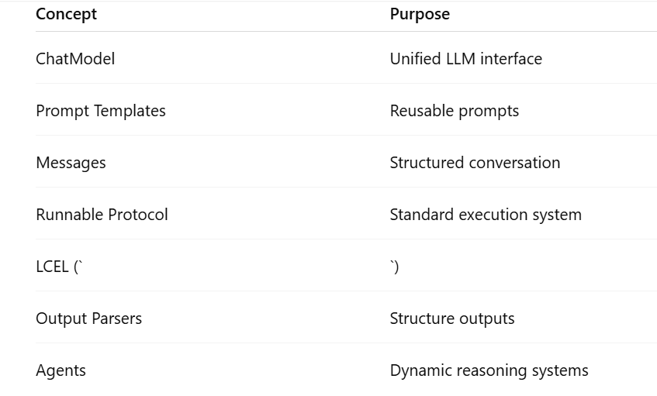

PART 1 — LangChain Chat Model Abstraction
Problem LangChain Solves, Every provider has different SDKs.
OpenAI
client.chat.completions.create(...)
Anthropic
client.messages.create(...)
Gemini
Different again
Groq
Different again
LangChain Idea: LangChain wraps ALL LLM providers behind ONE common interface.
That abstraction is called: ChatModel

Example ChatGroq ( chat + model )
Using Groq through LangChain:
from langchain_groq import ChatGroq
llm = ChatGroq(model="llama-3.3-70b-versatile", temperature=0, api_key=api_key)
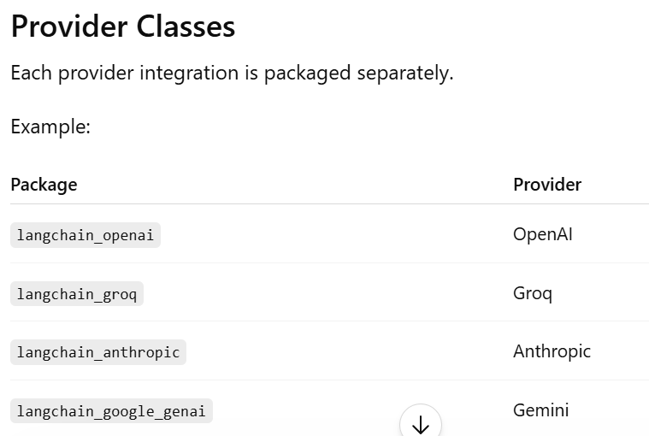
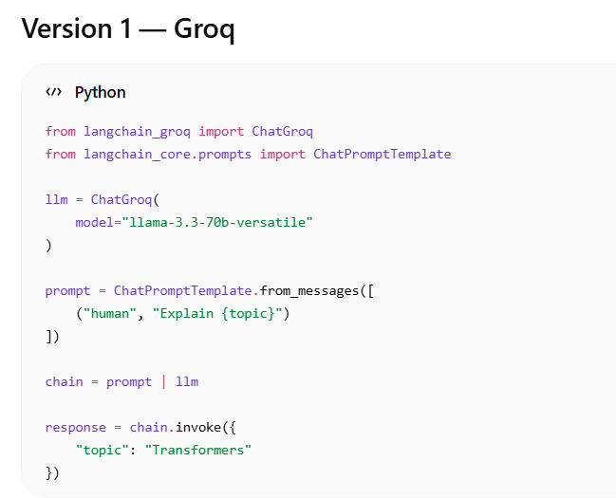
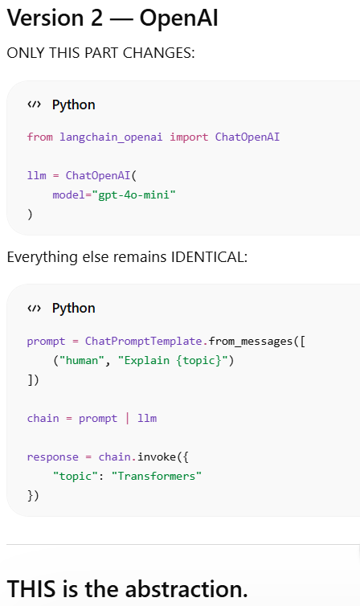
LangChain standardizes the INTERFACE.

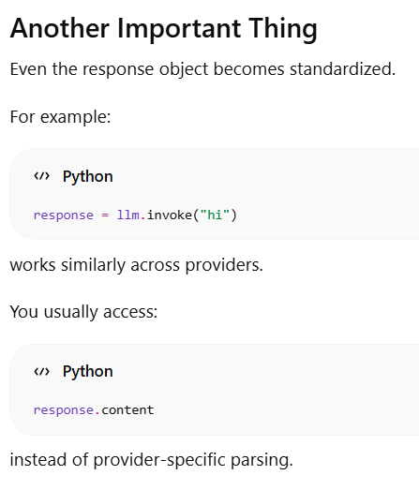

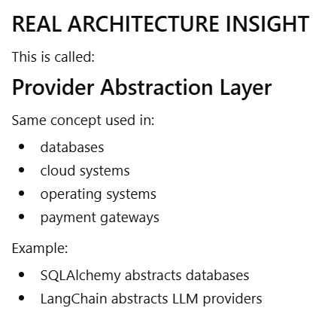

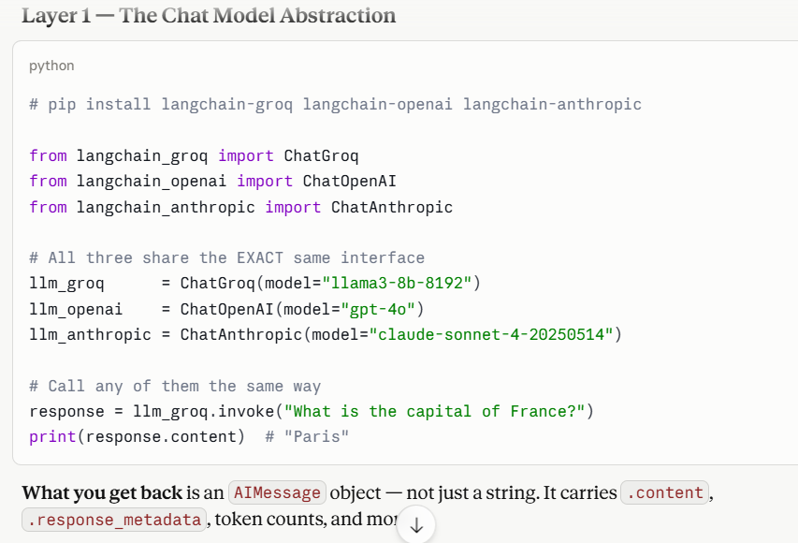

======================Runnable Protocol============================

Langchain has many components:
• prompts
• models
• parsers
• retrievers
• chains
• tools
all follow ONE execution contract. That contract became: Runnable Protocol
Simple Definition
A Runnable is:
Any object that can take input, process it, and produce output in a standard way.
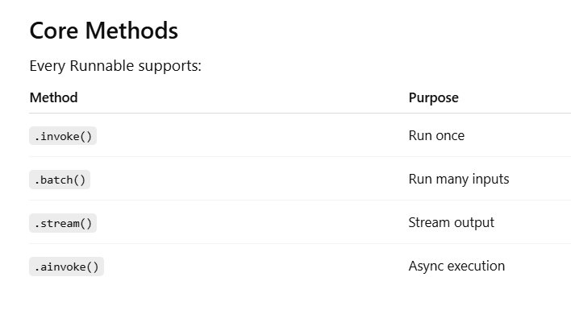
BIG Insight:
This means:
PromptTemplate is runnable.
ChatModel is runnable.
OutputParser is runnable.

Lets first see how LangChain Works:
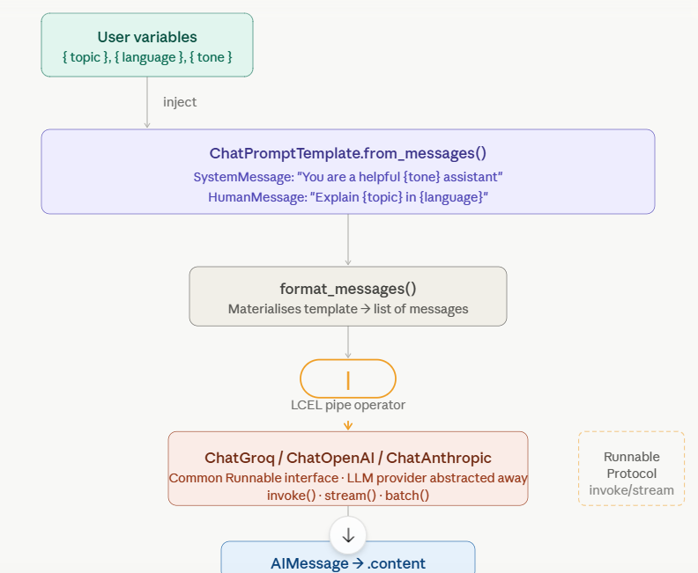

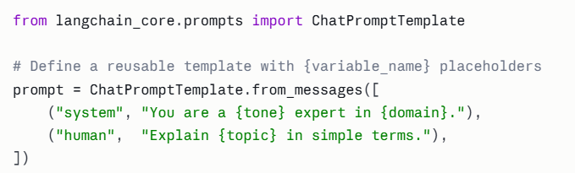
from_messages () accepts a list of tupple (role, template_string)— or actual message objects.
The {curly_braces} are your variable slots.
We need format_messages() to materialize the ChatPromptTemplate. Before you send anything to a model, you materialise the template — substituting the variables with real values.
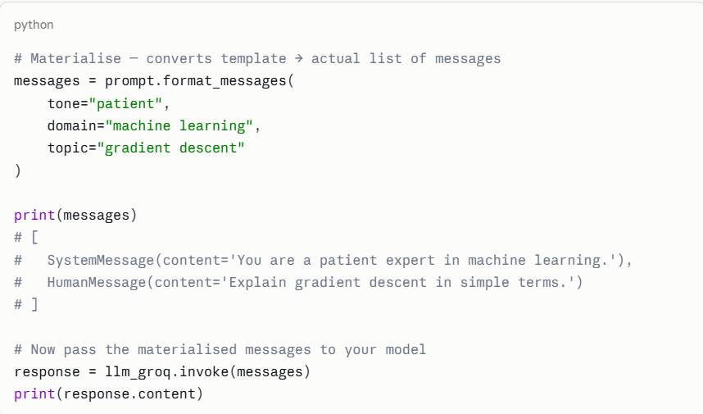

Lets try to understand Runnable again, The LCEL Chain (the | operator), This is where LangChain earns its name. The LangChain Expression Language lets you compose runnables with | — just like Unix pipes.

In above code we first defined prompt with place holder, used format_message over the prompt to pass variable values, then pass everything to llm_groq( which is chat model)
The same code , using LCEL and runnable concept can be written as:

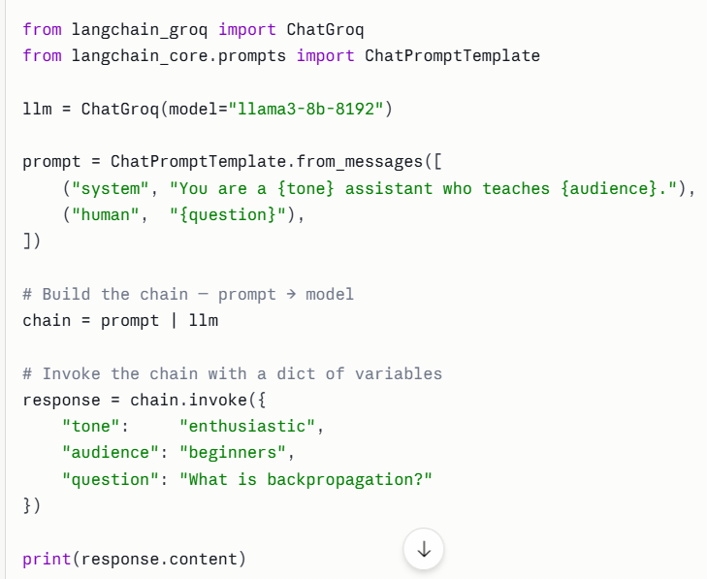
The code looks less messy.
Note in above code:
# Both prompt AND llm are Runnables
# So you can connect them with the | symbol chain = prompt | llm
# Now the chain itself is ALSO a Runnable # So it also has .invoke(), .stream(), .batch()

Under the hood, prompt | llm creates a RunnableSequence. When you call .invoke(), it:
- Passes your dict into prompt → calls format_messages()
- Passes the messages into llm → calls .invoke() on the model
- Returns the AIMessage
You can extend the chain further — prompt | llm | output_parser | another_step — as many links as you need.

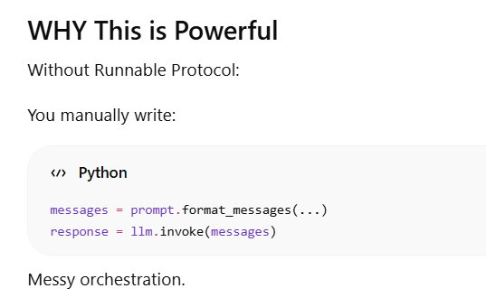
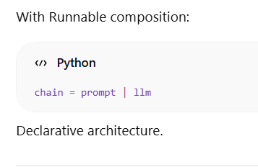
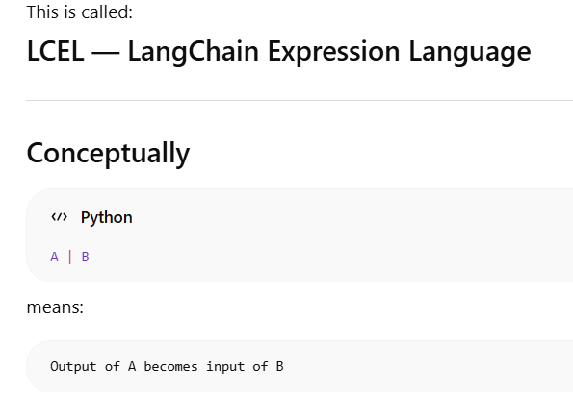

====================Messages: The Currency of LangChain====================

LangChain has three message types:

